**Department of Computer Science and Engineering**

Smart Farmer-IOT Enabled Smart Farming

Application

**IBM NALAIYATHIRAN**

# SPRINT – 3

|  |  |
| --- | --- |
| **TITLE** | **Smart Farmer-IOT Enabled Smart Farming Application** |
| **DOMAIN NAME** | INTERNET OF THINGS |
| **TEAM ID** | PNT2022TMID41868 |
| **LEADER NAME** | Sulochana A |
| **TEAM MEMBER NAME** | Swetha S  Keerthana P  Pavithra |

**Configuration of Node-Red to send commands to IBM cloud**

ibmiot out node I used to send data from Node-Red to IBM Watson device. So, after adding it to the flow we need to configure it with credentials of our Watsondevice.

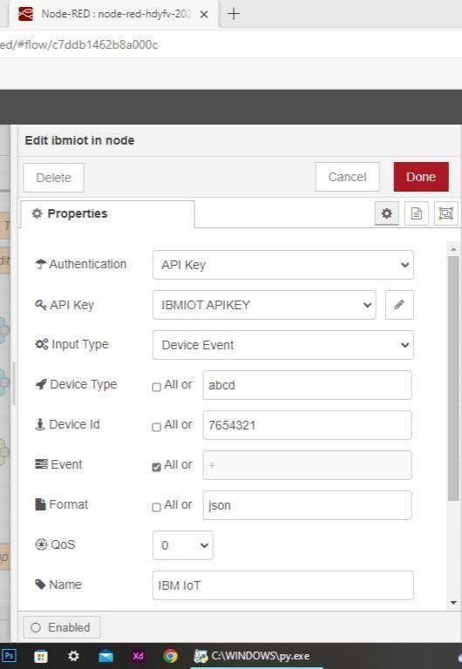

Here we add two buttons in UI

1 -> for motor on 2 -> for motor off

We used a function node to analyses the data received and assign command to each number.

The Java script code for the analyses is: if(msg.payload===1) msg.payload={"command”: “ON"}; else if(msg.payload===0) msg.payload={"command”:

“OFF"};

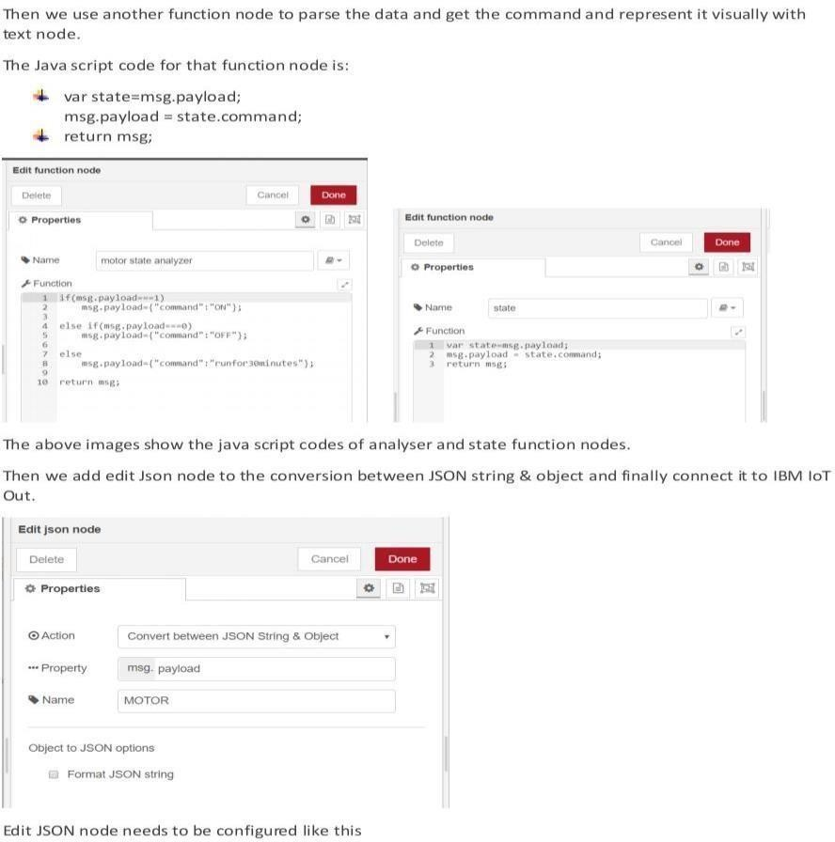

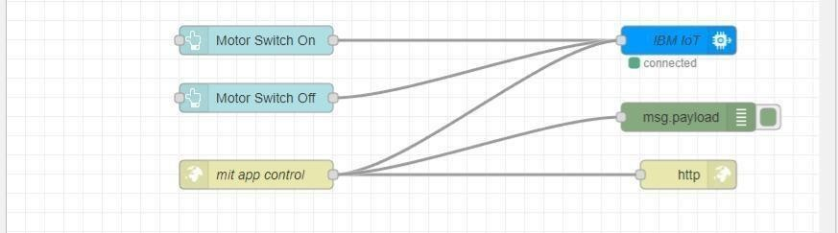

This is the program flow for sending commands to IBM cloud.

## Adjusting User Interface

In order to display the parsed JSON data a Node-Red dashboard is created

Here we are using Gauges, text and button nodes to display in the UI and helps to monitor the parameters and control the farm equipment.

Below images are the Gauge, text and button node configurations.

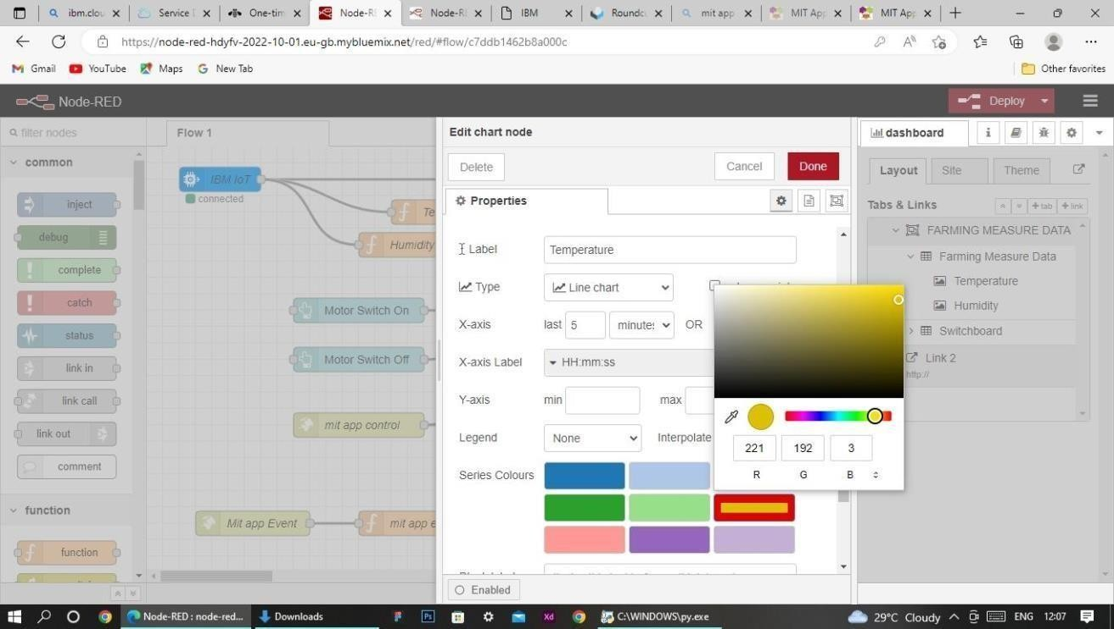

## Complete Program Flow

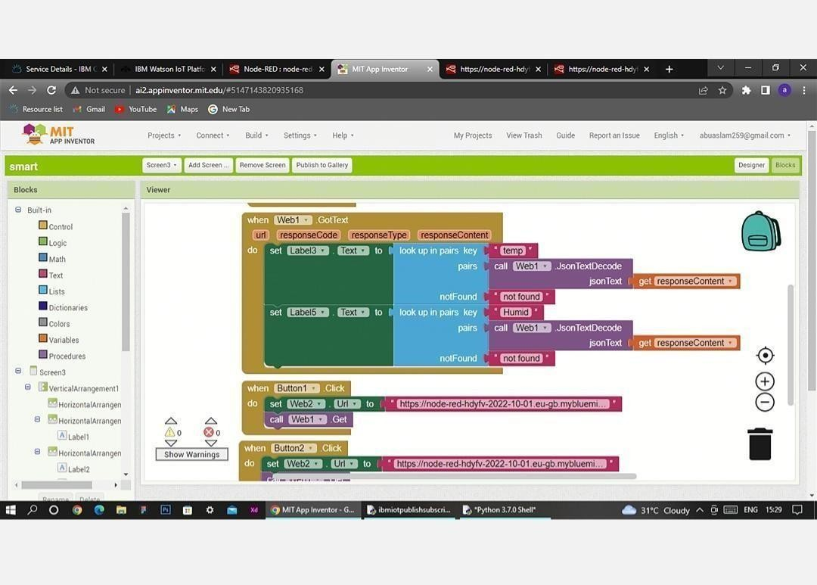MOBILE APP WEB :

# BLOCK DIAGRAM

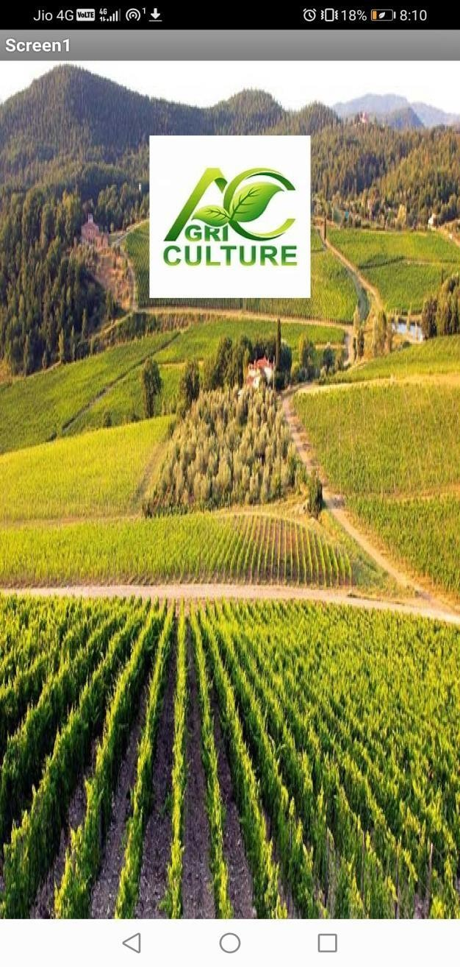 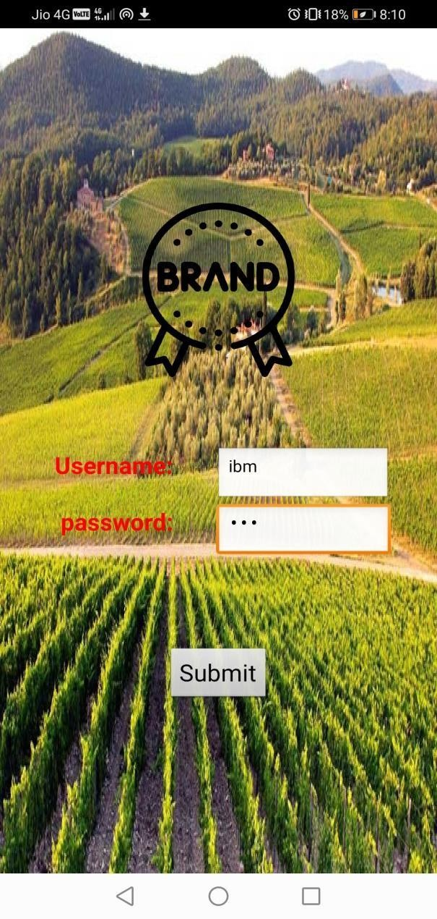

# SCREEN – 1 SCREEN - 2

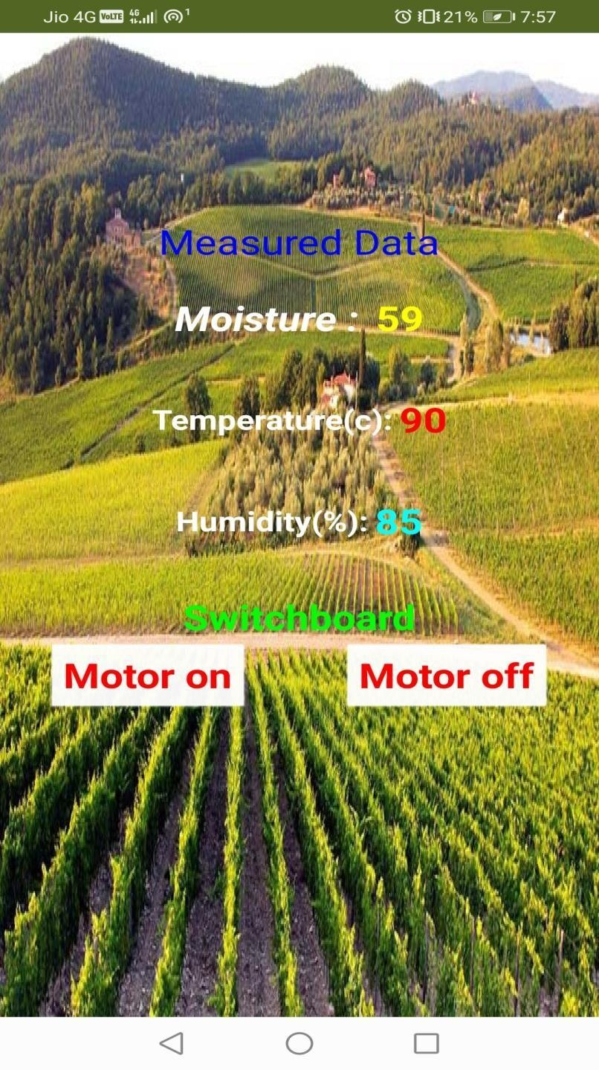

**SCREEN - 3**

## Web APP UI Home Tab

